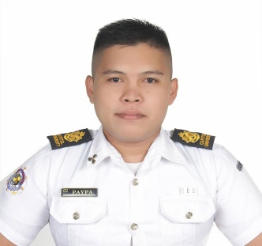
Name: | Paypa, Genn Vincent G.
Position Applied: |  | ENGINE CADET

Citizenship: | Filipino | Date of Birth: | 04 | April | 1992
Place of birth: | Iligan City | Age: | 26 Years Old
Height:(cm) | 170cm | Weight: (Kg) | 73kg

Personal Information:
Permanent Address: | Sta. Elena Iligan City Lanao del Norte
Tel. No: | None |  | Facebook Account: | facebook.com/gennvincentpaypa
Personal Cell no. | 09278674015 |  | Email. Address: | Nickey19.vp@gmail.com
Father’s Name: | Genaro B. Paypa |  | In case of Emergency Mobile Phone No.: | 09055463331
Mother’s Name: | Estrella G. Paypa

Educational Background:
 | Name of Institution |  | Year Graduated  From To |  | Institution Address
College(s): | Capitol University |  | 2015 | 2018 | Corrales Extn. Cagayan de Oro City, 9000, Phil.
 | Lyceum Of Iligan |  | 2009 | 2010 | Corpus Christi, Iligan City, 9200, Phil.
High School: | Tomas Cabili National High School |  | 2005 | 2009 | Tominobo Iligan City, 9200,Phil.
Elementary: | AJMMS |  | 2000 | 2005 | Sta. Elena Iligan City, 9200, Phil.

Trainings Completed:
Training | Completion Date |  |  |  | Certificate No. | Training Institution
Basic Training (BT) | 10th | December |  | 2014 | BT-14B123-14 | City of Manila
Security (SDSD ) | 22th | November |  | 2014 | SD 1411243 | City of Manila
Engine Watchkeeping | 27th | April |  | 2018 | RFPEW-0418-03-019 | City of Cagayan de Oro
Consolidated Marpol | 21th | November |  | 2014 | MAIVI-1411219 | City of Manila
PSCRB | 1 | December |  | 2014 | PSCRB-14B101-16 | City of Manila

Documents:
 | No. | Issue Date |  |  |  | Place of Issue | Expiry Date
SIRB | C1246751 | 9th |  | May | 2018 | City of Cagayan de Oro | 6th | May | 2028
E.Registration | 2018060803136 | 8th |  | June | 2018 | City of Manila
Passport | EC2680825 | 10th |  | Nov. | 2014 | City of Cagayan de Oro | 9th | Nov. | 2019
TIN | 440-031-024 |  |  | Philhealth |  | 10-050193182-3
SSS | 0511594283 |  |  | Pag-Ibig |  | 1211-4036-4552

Awards/School Club/Skills:
JUMARS CLUB member | 2015-2018

Character Reference:
Name | Position | Company
Capt. Douglas A. Gamonez, FICS | Vice-Dean / STO | Capitol University
Ms. Josefina Matris | Yatch Steward | Inter Crew
Mr. Guillermo G. Artienda | GP Yatch | Inter Crew

